POOL OPENS JUNE 25, 2022
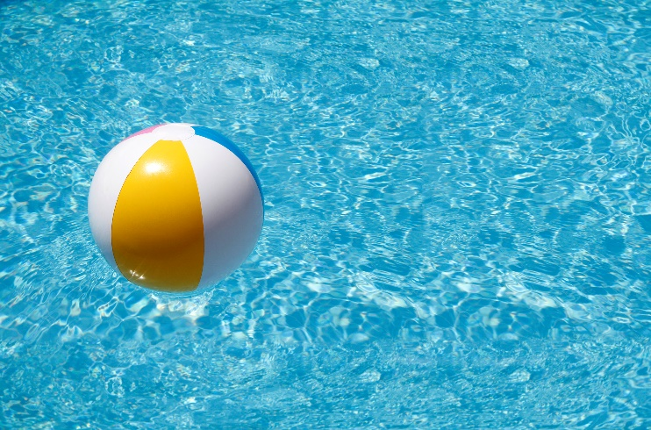
Swimming Hours:
Monday - Friday
12pm - 7pm
Saturday & Sunday
10am - 7pm
*Swim lessons start July 6,2022

